**Lab Practical #05:**

Study the application layer protocol DNS, DHCP, FTP.

**Practical Assignment #05:**

1. **Implement the application layer protocol DNS, DHCP, and FTP. Also check connectivity between them using ping command or PDU utility.**

**Instructions:**

1. Protocol-wise configuration setup screenshot.
2. Mention IP address of each pc as label.
3. Ping command or PDU screenshot between two pcs.

**DNS**

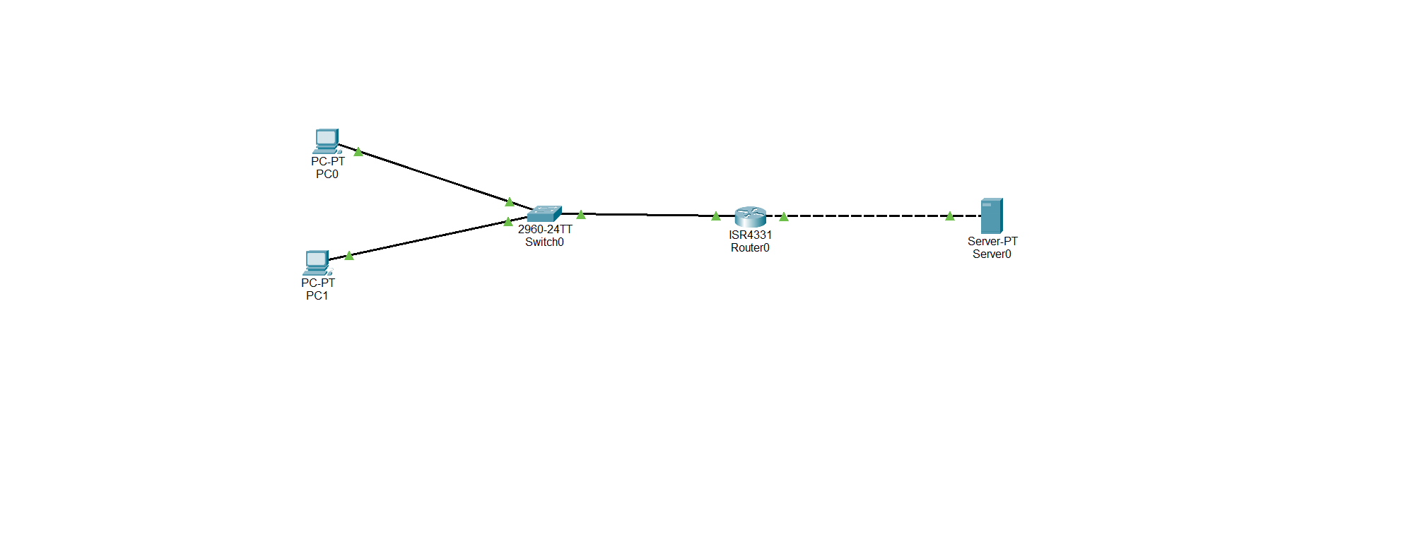

DNS Simulation

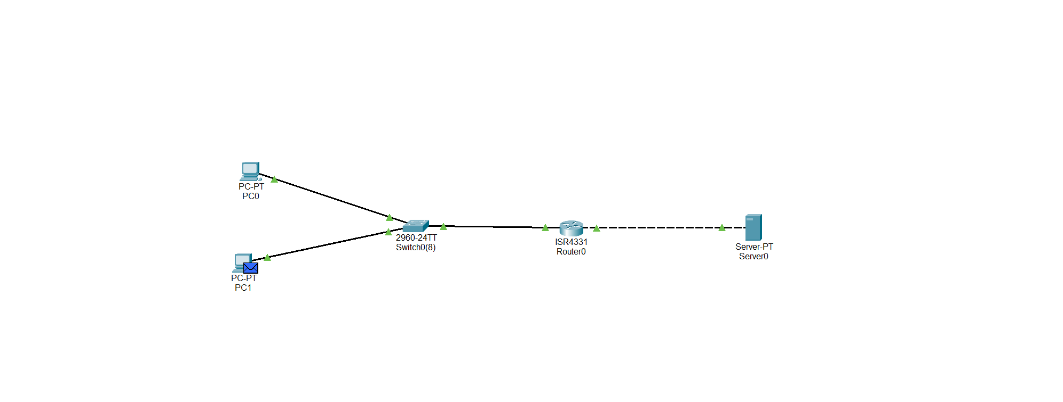

FTP

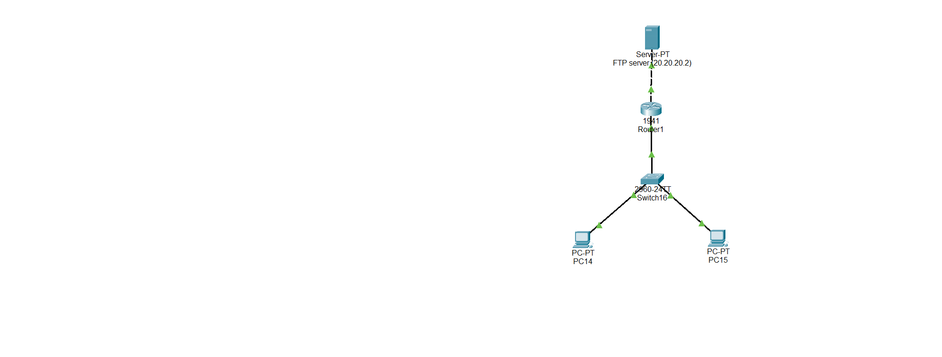

FTP Simulation

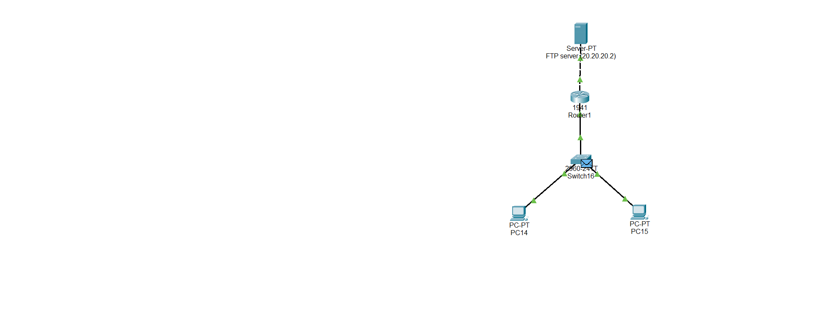

Bus Topology – DHCP

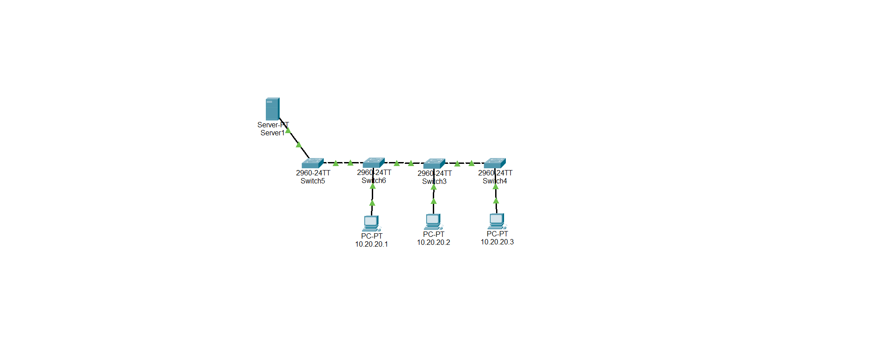

Bus Topology Simulation DHCP

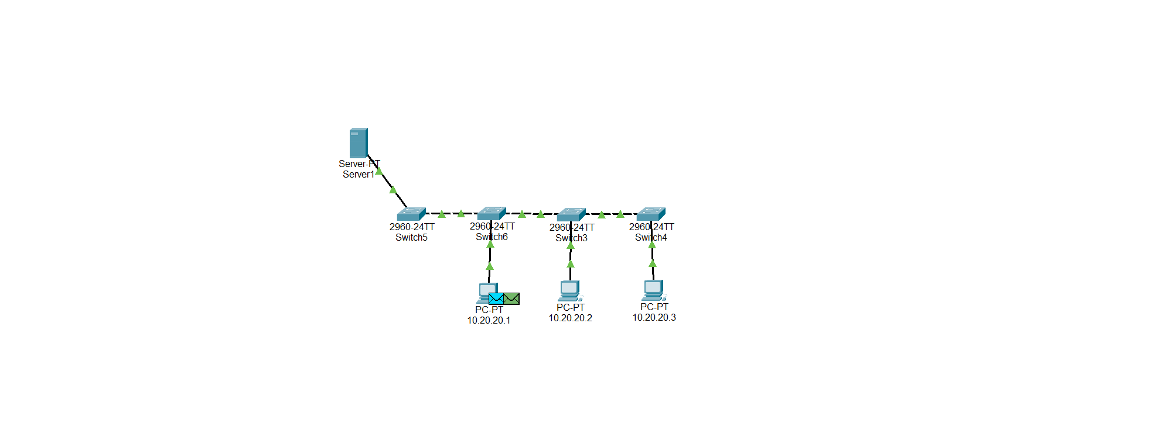

Mesh Topology DHCP

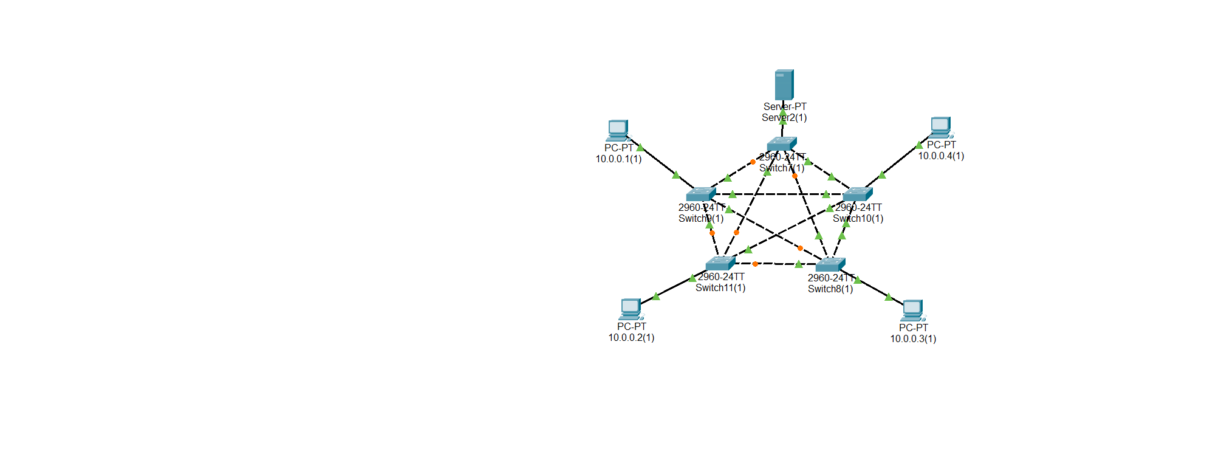

Mesh Topology Simulation DHCP

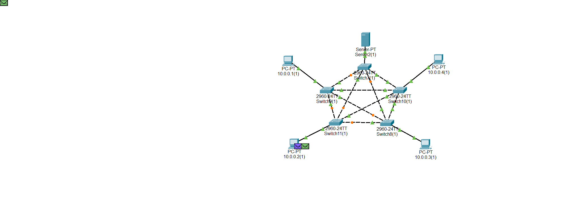

Ring Topology DHCP

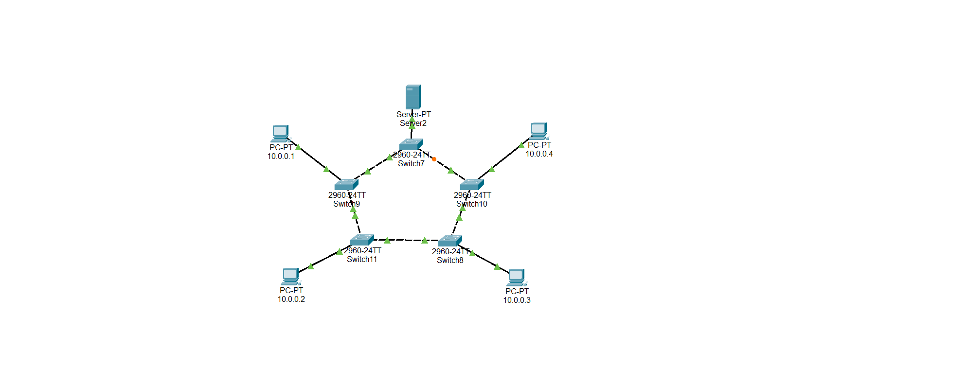

Ring Topology Simulation DHCP

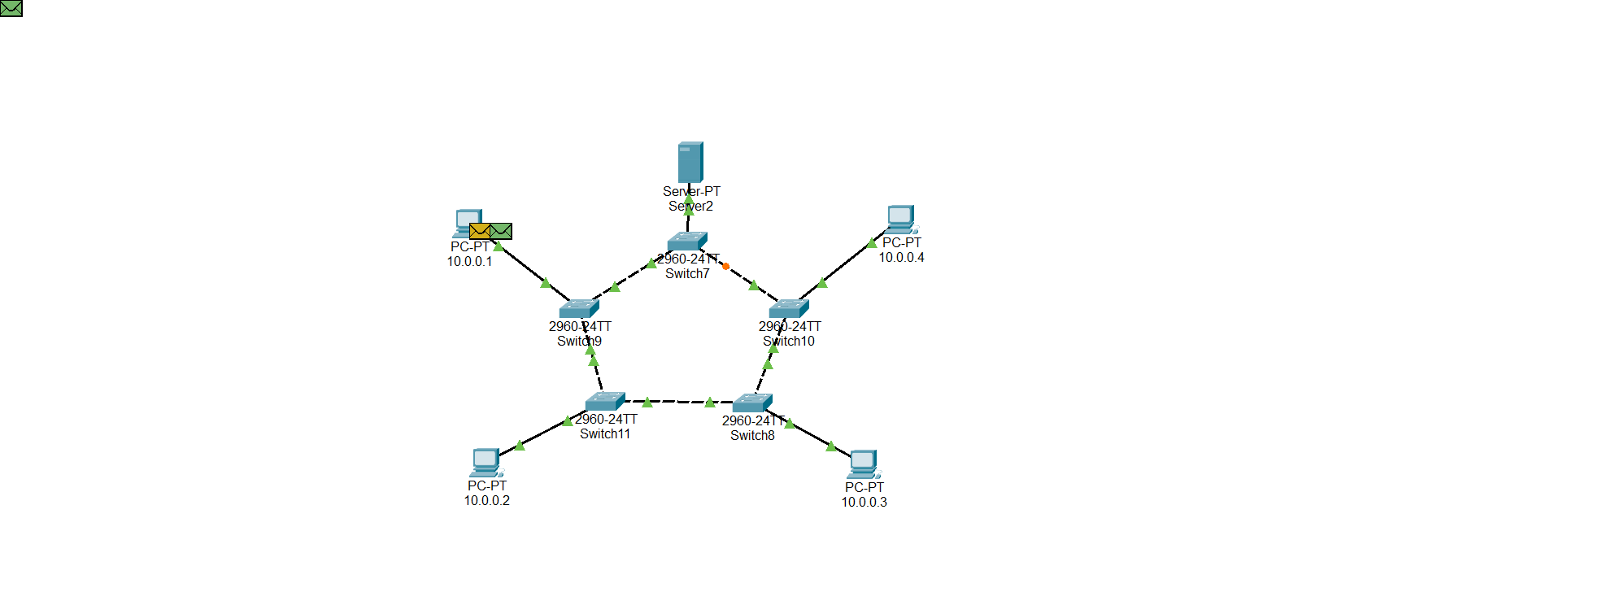

Star Topology DHCP



Star Topology Simulation DHCP



Tree Topology DHCP

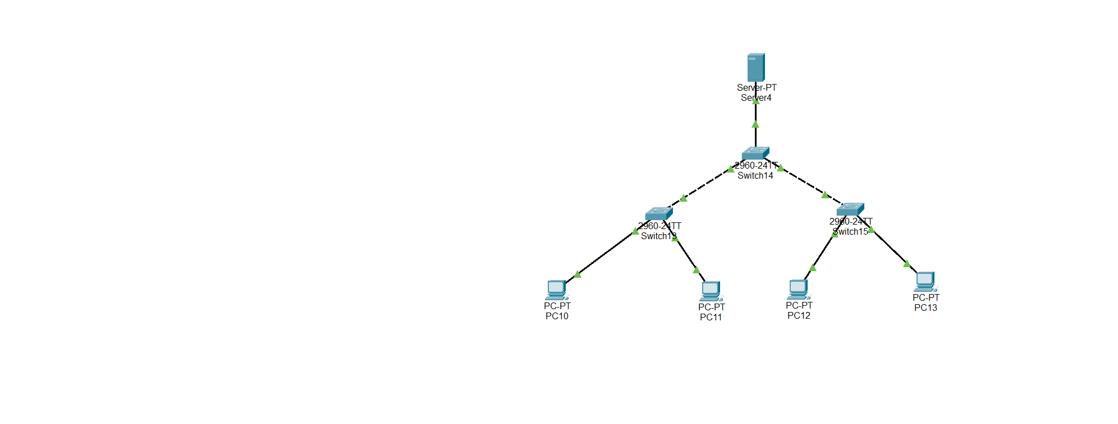

Tree Topology Simulation DHCP

